1. If you are loading both ETCs and Status, load ETCs first.
2. **If you are loading ETCs after CAM meetings**, the fields you will need are Control Account Number, OBS, Work Package and ETC value.
3. **If you are loading ETCs that were changed after loading actuals and calculating forecast,** determine which work packages had ETC changes (not affected by actuals) after calculating the Forecast. The end value you are looking for is ETC, not EAC. The information you will need from this file is the Control Account Number, OBS, Work Package and ETC value.
4. You will prepare two files for importing the ETC information. One is an **Activity file** and the other is a **Resource file**. The two additional pieces of information you need is Forecast Start Date and Forecast Finish Date.
5. Open a blank Excel file and copy the Control Account Number, OBS, and Work Package into a blank worksheet in this file. Label the fourth column “ID” and copy the Work Packages into this column. These columns will be exactly the same. Label the fifth column “Forecast Start”, and the sixth column “Forecast Finish”. Your file should be formatted like this:

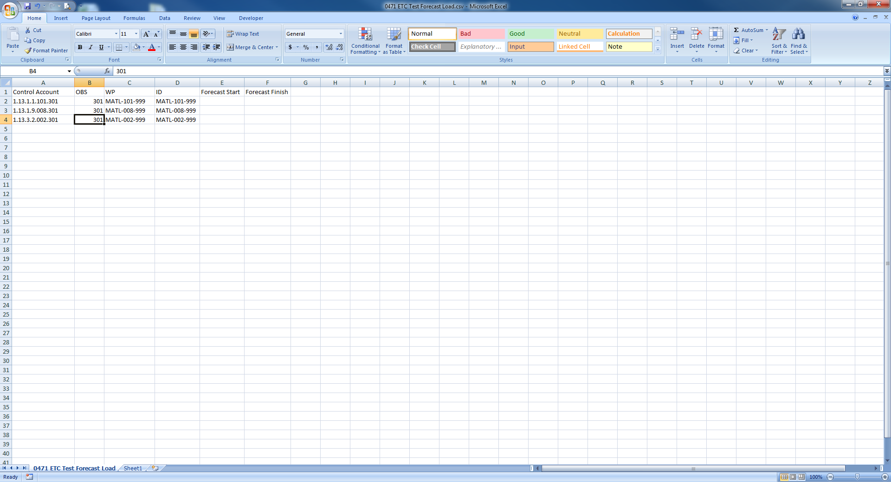

1. Name this file the **Activity File**. You will add the dates to this file later.
2. Open another blank Excel file and copy the Work Package and ETC value into a blank worksheet in this file. Insert a column between Work Package and ETC and label this column “Resource”. Enter “MATL” in every cell down the entire column except for the ODC activities. Enter “ODC” as the resource for those Work Packages. Label the first three available columns to the right “Forecast Start”, “Forecast Finish”, and “Class”. Select the ETC column and format as a number **without** the comma separator. In the Class column, enter “Forecast” all the way down the column. Your file should be formatted like this:

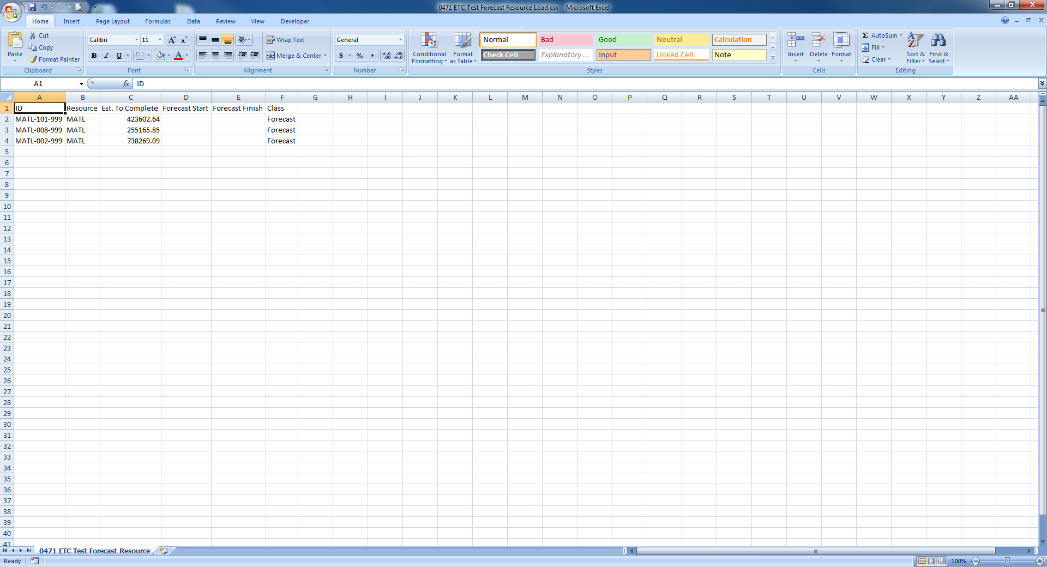

1. Name this file the **Resource file**. You will add dates to this file later.
2. Open your program in Cobra and expand all. With your cursor in the column header on the CAWP Pane, right-click and select **Insert Column**. Click the dropdown for Field Name and select **Forecast Start**. Do the same again to insert the **Forecast Finish**. Both are placed as the last columns. Drag both columns to right after the WP.

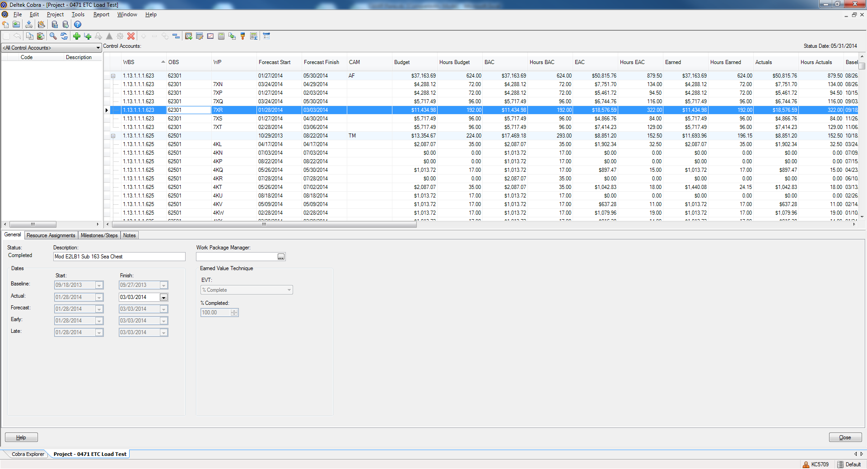

1. Copy the CAWP Pane (Edit>Copy CAWP Pane). Open this file and copy the worksheet to a blank worksheet in the Activity file.
2. In the **Activity file**, perform a vLookup to the worksheet you copied the CAWP data into to bring in the Forecast Start Date and Forecast Finish Date. Turn on filters and display any Forecast Finish Dates within the current month. These need to be changed to the next month. For example, if you are processing June, the Finish Date must be in July or later. Open the **Resource file** and copy the Work Package, Forecast Start Date and Forecast Finish Date from the **Activity file** to a blank worksheet in the **Resource file**. Save and close the **Activity file**.
3. In the **Resource file**, perform a vLookup to the worksheet you copied the **Activity file** data into to bring in the Forecast Start Date and Forecast Finish Date. Change all the Start Dates to the first workday after month-end. For example: If month end is 6/28/2014, enter 6/30/2014. Save and close this file.
4. In Cobra, start the Integration Wizard. Select Project Data. Click Next.
5. Select the radio button to Open an existing configuration. Navigate to and select your ETC load file. Click Next.
6. Check the boxes for Control Account and Work Package, and Resource Assignments. Click Next.
7. Click the ellipsis for Activity File, navigate to and select the Activity file you just created.
8. Click the ellipsis for Resource Assignment File, navigate to and select the Resource file you just created.
9. Select your project. Click Next.
10. The field mapper should already be set with the order of the fields in the Activity File. Click Next.
11. Click Next on the Earned Value screen.
12. The Resource Assignments screen should look as follows: Click Next.

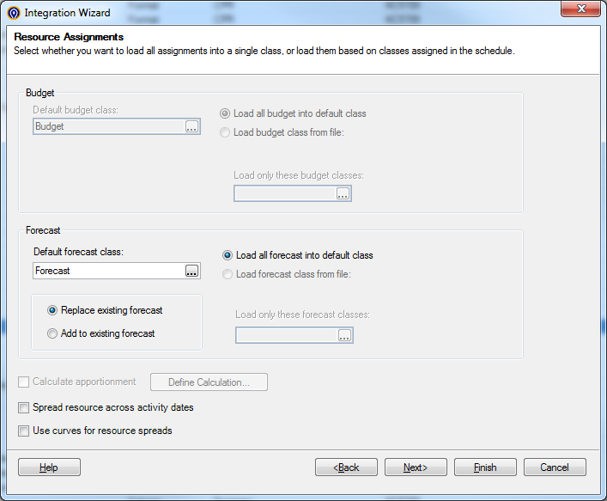

1. The Change Control screen should look as follows: Click Next.

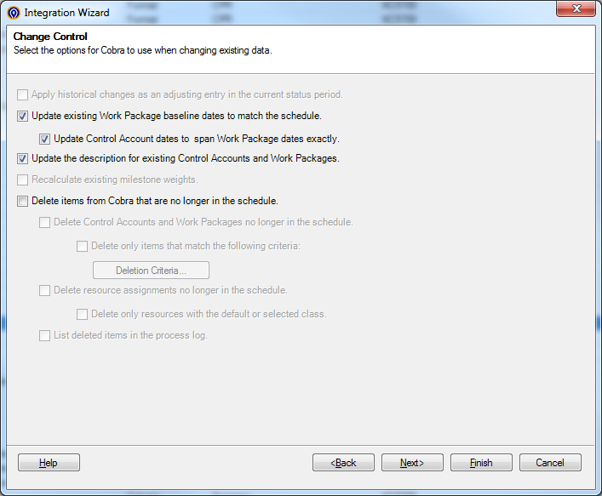

1. On the filter screen, select Work Package as the criteria and select all the Work Packages for the selection. Click Next.

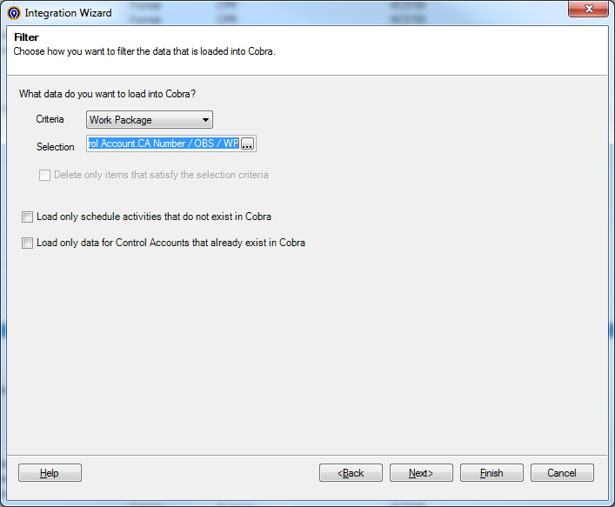

1. Don’t check the box to load resource codes as non-significant. Click Next.
2. Save if you want, otherwise click Finish.